Indigenous and Cultural Books
Order Form 2014

Allow at least 21 days for delivery. However, there may be some delay in the delivery of certain titles due to delays in sourcing them from publishers. We appreciate your patience in this matter. Please print clearly in block letters.

Date:
Purchase Order No.
(your organisation’s PO Number or create your own)
Let’s Read Community Name and ID:

Billing Address
Organisation name:
Address:
Suburb/Town: State Postcode
Contact Person:
Phone number:
Email:

Delivery Address (Delivery Instructions to be printed on package)
Attention: Contact Ph. No.
Organisation Name:
Address:
Suburb/Town: State: Postcode:
Payment details
□ Invoice
□ Prepay with cheque made payable to: The Smith Family
□ Credit card (please ensure all details are completed fully)
Amount $__________ Card type: □ Bankcard □ Mastercard □ Visa □ Amex
Card number: _________-_________-_________-_________ Expiry date ____/____
Name on card:
Signature:

Submit this completed resources order form to:
Let’s Read Operations Manager, The Smith Family
Email: metty.joseph@thesmithfamily.com.au
Fax: (03) 9415 8625

We respect your privacy. For full details of The Smith Family's Privacy Policy, please visit www.thesmithfamily.com.au

Order Form continued

Books for purchase | Quantity | Unit Price | Total Price
Books suitable for: From 4 months
- Budburra's Alphabet (IND) |  | $18.00
- Australian Babies (CUL) |  | $8.00
- W is for Wombat: My first book of Australian Words (IND) |  | $7.00
- Say Goodnight (CUL) |  | $7.00
- Animals - An Indigenous First Discovery Book |  | $9.00
Books suitable for: From 12 months
- Possum & Wattle by Bronwyn Bancroft (IND) |  | $15.00
- People and Places – An Indigenous First Discovery Book (IND) |  | $9.00
- An Australian 123 of Animals (IND) |  | $7.00
- Hands Can (CUL) |  | $7.00
Books suitable for: From 18 months
- At the Billabong - An Indigenous First Discovery Book |  | $11.50
- Aussie Toddlers can (CUL) |  | $8.00
- Big rain coming by Katrina Germein (IND) |  | $8.00
- Aussie Twos like to... (CUL) |  | $8.00
- What We Count, Then and now (IND) |  | $11.50
Books suitable for: From 3 ½ Years
- My Body (IND) |  | $18.00
- Counting (IND) |  | $18.00
- How the Birds got their Colours (IND) |  | $7.00
- Budburra’s Garden (IND) |  | $18.00
Books suitable for: Group activities including big books
- SmartyCat Series – (SET 6 Books) - Rainbows, Thunder, Frogs, Butterflies, Nests & Teeth |  | $18.00
- Yo Yo Series: two books ( Yo Yo Helps & Yo Yo’s Toys) |  | $3.00
- Where’s My Teddy? ( Big Book) |  | $20.00
- Handa’s Surprise ( Big Book) |  | $20.00
- We’re Going on a Bear Hunt ( Big Book) |  | $20.00
- My Little Library - Me and You |  | $10.00
- My Little Library - Kisses for Daddy |  | $10.00
- My Little Library - Kiss, Kiss! |  | $10.00
- I love my family (SET 4 Books) - I love my Dad, I love my Mum, I love my Grandpa & I love my Grandma |  | $16.00
- The Wonky Donkey |  | $9.00
- The Gruffalo |  | $9.00
SUBTOTAL
Freight 5% of cost of order
SUBTOTAL
Plus GST (10%) |  | +
TOTAL

Books suitable for: From 4 months

Book title and cost | Description | Book cover
- Budburra's Alphabet Created by Cherbourg State School  Cost: $18.00 | Budburra’s Alphabet. Follow Budburra’s path through the alphabet while enjoying a fun play on words. Text and illustrations by Cherbourg children.
- Australian Babies (CALD)  Published by Magabala Books  Cost: $8.00 | This delightful picture board book is dedicated to babies across Australia. Rich with the vibrant colours of the landscape, these beautiful photographic images reflect Australia. | 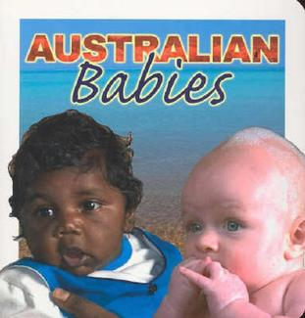
- W is for Wombat: My First Book of Australian Words  by Bronwyn Bancroft  Cost: $7.00 | ‘W is for Wombat’ is stories taken from the best-selling Possum and Wattle, and provides a different experience for a younger audience. Each page depicts an Australian word taken from the original book, and is lavishly illustrated by Australian best-selling children's illustrator and artist, Bronwyn Bancroft. | 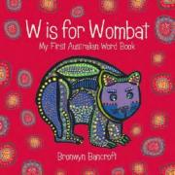
- Say Goodnight (CALD)  by Helen Oxenbury  Cost: $7.00 | An entertaining cast of playful toddlers prepares to go to bed, in a new version of a popular board book, complete with a newly designed cover, from the illustrator of We're Going on a Bear Hunt. | 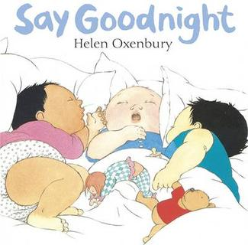
- Animals : An Indigenous First Discovery Book  Artwork by Debbie Austin  Cost: $9.00 | 'Animals' is the first title in the delightful Indigenous First Discovery Series by acclaimed Koorie artist Debbie Austin.  This beautifully illustrated babyboard book introduces pre-schoolers and parents to the Indigenous symbols for Australian animals, such as the koala, emu and kangaroo. With each page colourful and bold, 'Animals' stimulates baby's vision and curiosity while encouraging a valuable connection with Australia's cultural heritage. | 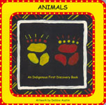

Books suitable for: From 12 months

Book title and cost | Description | Book cover
- Possum and Wattle:  My Big Book of Australian Words  by Bronwyn Bancroft  Cost: $15.00 | An eye-opening vocabulary book featuring words taken from Australia’s inspiring natural environment with a glossary of Aboriginal terms. More than 100 words about Australian animals, plants, and landscapes are defined and explained in this unique word book. From blossoms and bees through wombats and willy willys, the most prominent aspects of Australia’s beautiful landscape are detailed here. Lavish illustrations range from small vignettes to expansive narrative landscapes and both captivate and celebrate the uniqueness of Australia and its language. | 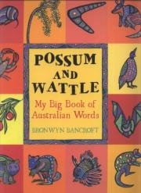
- People and Places:  An Indigenous First Discovery Book  Artwork by Debbie Austin  Cost: $9.00 | This beautifully illustrated babyboard book introduces pre-schoolers and parents to the Indigenous symbols for various places, people and elements. With each page colourful and bold, 'People and Places' stimulates baby's vision and curiosity while encouraging a valuable connection with Australia's cultural heritage. | 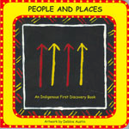
- An Australian 123 of Animals  by Bronwyn Bancroft  Cost: $7.00 | A delightful counting book of Australian animals by acclaimed indigenous artist Bronwyn Bancroft, this stunning picture book has lizards hissing and wallabies hopping  One platypus diving.  Two brolgas dancing.  Three koalas dozing.  Four crocodiles snapping.  Five kookaburras laughing…  The book is both a delightful introduction to the numbers one through 12 and a unique exploration of Australian wildlife, some familiar, others more unusual. The animals featured include sugar gliders, emus, geckos, wallabies, and many more. | 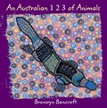
- Hands Can (CALD)  by Cheryl Willis Hudson  Photographs by John-Francis Bourke  Cost: $7.00 | For the very young, hands are a never-ending source of discovery. With singsong rhythm, simple design, and alluring color photos of toddlers, "Hands Can" invites children to discover the many things hands can do.  An excellent introduction for toddlers to the wonders of their own body. | 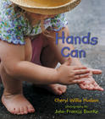

Books suitable for: From 18 months

Book title and cost | Description | Book cover
- At the Billabong: An Indigenous First Discovery Book  Story and Artwork by Debbie Austin  Cost: $11.50 | At the Billabong by Debbie Austin is the third Indigenous First Discovery Book, and tells a gentle bush tale that draws on the symbols from the first two books 'Animals' and 'People and Places'. The design encourages young children to be interactive with each page, while the rich alliterative language will capture their attention. | 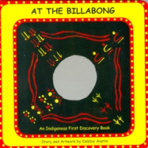
- Aussie Toddlers Can  Published by Magabala Books  Cost: $8.00 | Aussie Toddlers Can shows toddlers doing all those wonderful things that toddlers do—playing, dancing, eating, and more. Each page is brightly coloured with funky images, and to add to the fun, there is a mirror in the inside back cover. | 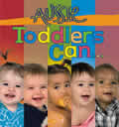
- Big Rain Coming  by Katrina Germein  Illustrated by Bronwyn Bancroft  Cost: $8.00 | A lyrical story about waiting for the rain to come to an isolated Aboriginal community. Tension in the community builds as the rain clouds thicken and grow dark. Everybody waits. When will the rain come? | 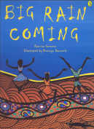
- Aussie Twos Like To... (CALD)  Published by Magabala Books  Cost: $8.00 | Aussie Twos Like To... reflects Australia's rich multicultural society and shows Aussie two-year-olds doing all the things they love - digging at the beach, finger painting, building blocks, dress-ups and more. Each page is brightly coloured with funky Aussie images and lots to learn! The third board book in the Aussie Kids' Series, Aussie Twos Like To... is set to follow the success of Australian Babies and Aussie Toddlers. | 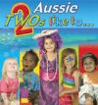
- What We Count, Then and Now  by Helen Empacher, Bianca Briggs, Tu Roper, Nioka Doolan and Ernie Blackmore and Bronwyn Bancroft  Cost: $11.50 | What We Count, Then and Now by Helen Empacher, Bianca Briggs, Tu Roper, Nioka Doolan and Ernie Blackmore is a simple counting book in which the pictures compare related everyday, useful objects used in Australia before 1788 and their modern counterparts. | 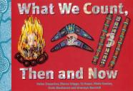

Books suitable for: From 3½ years

Book title and cost | Description | Book cover
- My Body  Created by Guluin Pre-Prep Class- Cherbourg State School  Cost: $18.00 | Cherbourg’s Pre-Prep children pose for photographs and demonstrate Standard Australian English names for parts of the body.
- Counting  Created by Milbi Class- Cherbourg State School  Cost: $18.00 | Learn to count from one to ten with Cherbourg children in Yr. 1. The children have painted some familiar things from their world, snakes, hands, feet, boomerangs, crabs and clap sticks.
- Budburra's Garden Created by Cherbourg State School  Cost: $18.00 | Budburra’s Garden introduces children (3-5 years) to the healthy eating concept of “eating a rainbow everyday” using colours and foods.  The book is artwork driven and very interactive, utilising repetition, descriptive words, visual clues and a back section including discussion points, fun recipes and bush tucker information. | 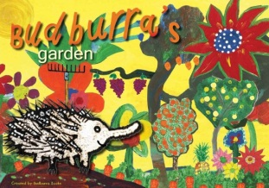
- How the Birds got their Colours  An Aboriginal Story  Told by Mary Albert  Compiled by Pamela Lofts  Cost: $7.00 | This book is based on a story told by Mary Albert of the Bardi People to Aboriginal children living in Broome, Western Australia. The illustrations are adapted from their paintings of the story. | 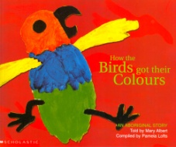

Books suitable for: Group activities including big books

All of these books have been selected for the value they add to group reading times.
Book title and cost | Description | Book cover
- SmartyCat Series – (SET 6 Books) - Rainbows, Thunder, Frogs, Butterflies, Nests & Teeth  By Jeannette Rowe and Louise Park  Cost: $18.00 |  | 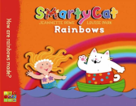  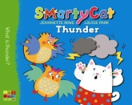  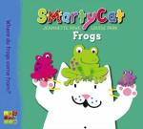  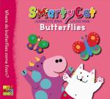  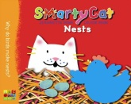  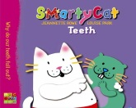
3. Where’s My Teddy? (Big Book)  by Jez Alborough  Cost: $20.00 | Eddie's in for the surprise of his life when he discovers that his teddy bear has grown much too big to cuddle. But there's fun in store when Eddie meets up with a real bear who's got just the opposite problem--his lost teddy bear has shrunk to a size that's much too small for such an enormous bear to cuddle. Could it be a case of mistaken identity? Full color. 32 pages. Great big version of great big favorites! | 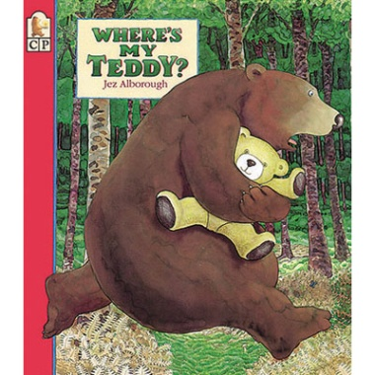
4. Handa's Surprise ( Big Book)  by Eileen Browne  Cost: $20.00 | Set in Africa, this picture book is about a girl's eventful journey with a basket of fruit. As she walks, carrying the basket on her head, various creatures steal her fruits. First published in paperback in 1995, illustrated in full colour. | 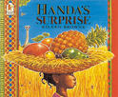
5. We’re Going on a Bear Hunt (Big Book)  by Michael Rosen and Helen Oxenbury  Cost: $20.00 | Brave bear hunters go through grass, a river, mud, and other obstacles before the inevitable encounter with the bear forces a headlong retreat. | 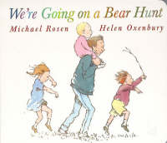
6. My Little Library - Me and You  by Janet A. Holmes and Judith Rossell  Cost: $10.00 | This delightful picture book is a series of reflections that the narrator, an endearing cloth rabbit, makes about himself and the things he can do. The brief text culminates with the ultimate reflection that the thing he likes best about being himself is that he can share his favourite activities with his friend, an equally endearing white mouse. The expressive illustrations complement the pared-back text with a subtle visual narrative.
7. My Little Library - The way I Love You  by David Bedford and Ann James  Cost: $10.00 | By David Bedford and Ann James  I love …  the way you always care,  the way you're always there.. .  That's the way I love you.  Told through beautifully observed moments between a little girl and her dog, 'The Way I Love You' is a joyous celebration of love and friendship.
8. My Little Library - Kisses for Daddy  by Frances Watts and David Legge  Cost: $10.00 | When a grumbly Baby Bear refuses to give his father a goodnight kiss, their bedtime routine is transformed into a delightful game, as Daddy imagines all the different sorts of kisses that other animal babies give their dads.  This warm, affectionate story is perfect for children and their daddies to share.
9. My Little Library - Kiss, Kiss!  by Margaret Wild and Bridget Stevens-Marzo  Cost: $10.00 | One day, when Baby Hippo woke up, he was in such a rush to go and play that he forgot to give his mum a kiss...  The story that follows is a delightful page-turner, as on his walk through the jungle, Baby Hippo hears Kiss, kiss! from an appealing assortment of parents and babies. Finally, he realises what it is he forgot to do...  With a charming text and stunning illustrations, 'Kiss, Kiss!' is a warm, affectionate story that will delight both children and their parents (who also like kisses!).
10. I love my family (SET 4 Books) - I love my Dad, I love my Mum, I love my Grandpa & I love my Grandma  by Anna Walker  Cost: $16.00 | Contains four books including: I Love My Mum, I Love My Dad, I Love My Grandma, I Love My Grandpa. Fall in love with Ollie-a gorgeous, lively zebra, Fred the dog and all of Ollie's family! Each of these books features Ollie sharing a special day with one member of his family-Mum, Dad, Grandma, Grandpa.  With Ollie, the everyday events of a young child's life are exciting adventures, brought to life by Anna Walker's whimsical rhyming texts and gorgeous illustrations. | 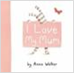  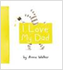  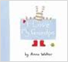  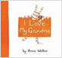  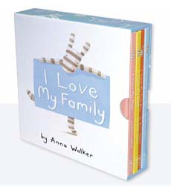
11. The Wonky Donkey (CD Included)  Words and music by Craig Smith  Illustrations by Katz Cowley  Cost: $9.00 | Children will be in fits of laughter with this perfect read-aloud tale of an endearing donkey. By the book’s final page, readers end up with a spunky,hankypanky,cranky,stinky,dinky,lanky,honky-tonky, winky wonkey, donkey!  There is much fun to be had by listening to the song and trying to predict the new word for each clue given! | 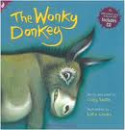
12. The Gruffalo  by Julia Donaldson and Axel Scheffler  Cost: $9.00 | A gruffalo? What's a gruffalo?  A gruffalo! Why, didn't you know? He has terrible tusks, and terrible claws, and terrible teeth in his terrible jaws.  A quick-witted mouse takes a stroll through the deep-dark wood. When Fox, Owl and Snake want to eat him, he makes up tales of a fearful Gruffalo to scare them.  But what will Mouse do when he stumbles upon a real live hungry Gruffalo? | 